For Immediate Release Media Contact
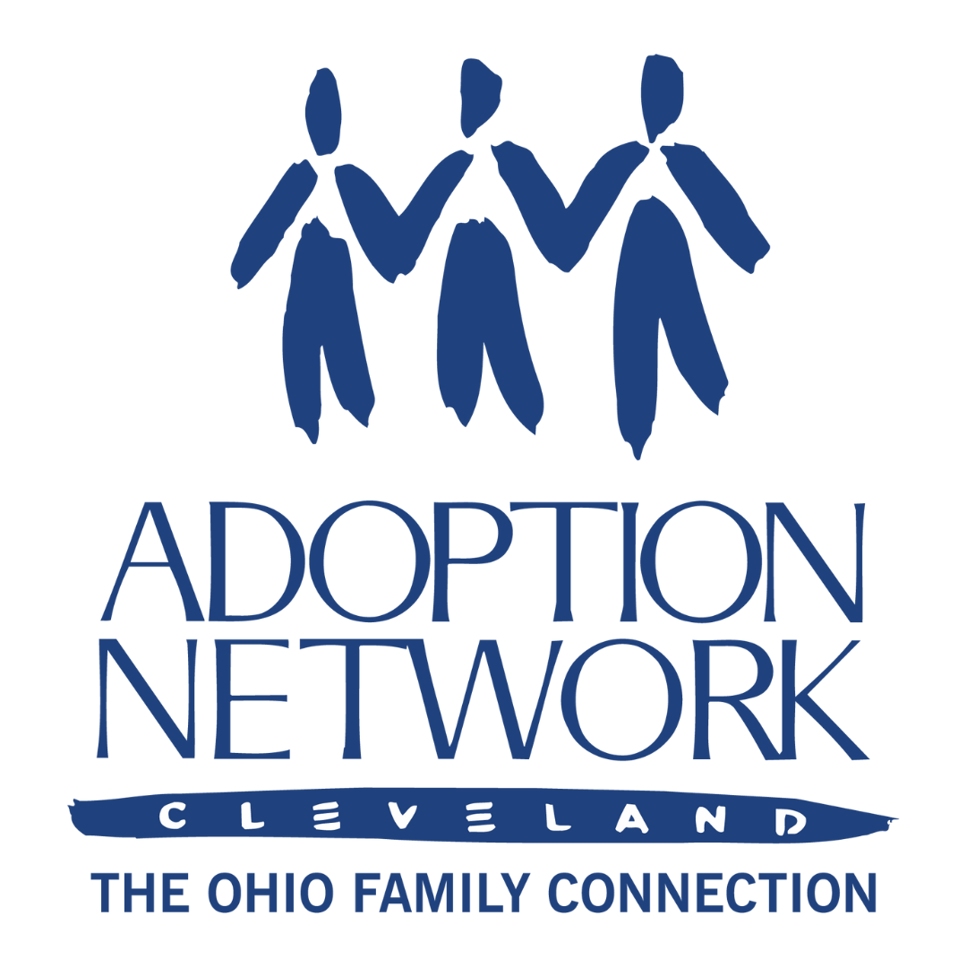
Kill 10.30.23 Betsie Norris
Executive Director
(216) 482-2314
betsie.norris@adoptionnetwork.org

Savannah Johns Communications Coordinator
(216) 482-2311
savannah.johns@adoptionnetwork.org

Author Gretchen Sisson, Ph.D. Presents Exclusive Book Preview for Relinquished: The Politics of Adoption and the Privilege of American Motherhood, Oct. 30

CLEVELAND – October 16, 2023 – What can we learn from the experiences of women who have relinquished children for adoption? Adoption Network Cleveland and partners listed below are pleased to host Gretchen Sisson, Ph.D. on Zoom on Monday October 30th, 7:30-9:00 PM ET for a special preview of her upcoming book, Relinquished: The Politics of Adoption and the Privilege of American Motherhood.
This virtual book preview and conversation with the author is open to the public, and admission is free with a registration. If you would like to provide more information about this topic to your readers, Sisson and Adoption Network Cleveland Founder, Betsie Norris, are available for comment and interview.
“We are in a political moment in which adoption is, increasingly, being revealed as an institution devoted to separating families and policing parenthood under the guise of feel-good family-building,” Sisson writes. “Rooted in a long-term, qualitative sociological study, Relinquished is an analysis of hundreds of in-depth interviews with American mothers who placed their children for domestic adoption collected over a decade. The voices of these women are powerful and heartrending; they deserve to be heard as a response to this moment.”
-more-

Nationally recognized for her research on women’s experiences with adoption and abortion, Dr. Sisson’s studies on adoption include hundreds of in-depth interviews with women who have relinquished infants for adoption over the past 60 years, with a particular focus on women who have relinquished since Roe v. Wade. Her research examining adoption decision-making after abortion denial (as part of The Turnaway Study) was cited in the Supreme Court’s dissent in Dobbs v. Jackson Women’s Health from Justices Breyer, Kagan, and Sotomayor. In response to the oral arguments and decision in Dobbs, she authored pieces in the Washington Post, The Nation, and the Washington Post (again). Gretchen’s research has been featured on NPR’s All Things Considered and Consider This, as well as in New York Magazine, VOX, and other outlets.
Dr. Sisson will share insights from Relinquished that illustrate birth mothers’ reproductive decision-making, their life-long experiences of adoption, and why these stories matter for us in Ohio. The event will begin with remarks from the author, to be followed by a discussion and Q&A moderated by Kate Livingston, Ph.D., birth mother and founder of Ohio Birthparent Group (active 2010-2017).
For more information on the upcoming book, see: RELINQUISHED: The Politics of Adoption and the Privilege of American Motherhood. To register to attend, see: Evening with Gretchen Sisson, Ph.D. Partners on this event include:

About Adoption Network Cleveland
Adoption Network Cleveland: The Ohio Family Connection is an innovative non-profit organization with over 30 years of experience serving the adoption and foster care communities. Our organization fulfills otherwise unmet needs for information, advocacy, education and support for adult adoptees, birth parents and birth family; adoptive, kinship and foster families; youth in foster care and foster alumni; and related professionals. More recently, the organization has expanded its services to use its expertise in adoption search, reunion with birth family, and peer support networks to assist those who have been donor-conceived or have misattributed parentage. The organization can be found online at www.adoptionnetwork.org or on social media at @AdoptionNetCle.
###

